** ON THE RUK PAGE **

Barrie Rugby is pleased to offer our RUK (Rugby Unites Kids) Program.

This program has been offered for several years and continues to provide a great opportunity to provide youth and young adults the equal opportunity to participate in a fast, exciting, inclusive and fun sport that is growing within Canada.

“Barrie RFC is committed to developing children, youth and young adults through sport with the goal that no one is left out”

ADD THE RUK DOCUMENT HERE

**Alternative avenues for financial assistance**

<http://www.kidsportcanada.ca/ontario/georgian-bay/> (KidSport)

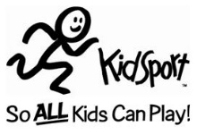

<http://jumpstart.canadiantire.ca/en/what-we-do> (Jumpstart)

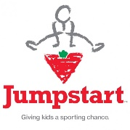

<http://www.cra-arc.gc.ca/fitness/> (Canada Fitness Tax Credit)



<http://youthreach.ca/> (YouthReach)

